FACULTY OF INFORMATION TECHNOLOGY
IT PROJECT 700 | GROUP 55

EMERGEX
  - Centralized Student Accommodation & Secure Booking Application
PHASE 2 - PLANNING
Need, feasibility, project plan, schedule, SRS and models
Supervisor: Thabiso | ThabisoA@richfield.ac.za | Semester 2, 2026
Student no. | Member | Email | Contact | Primary role
402308936 | Tristan Moses | 402308936@my.richfield.ac.za | 0828015082 | Project manager and frontend lead
402411668 | Reenesh Ramawthar | 402411668@my.richfield.ac.za | 0846041521 | Backend and quality engineering
402411227 | Joyce Kamalu | 402411227@my.richfield.ac.za | 0671075365 | Business analysis and documentation
402412304 | Novithan Naidoo | 402412304@my.richfield.ac.za | 0620829186 | Database and backend engineering
402413409 | Thingo Shezi | 402413409@my.richfield.ac.za | 0714299251 | UI/UX and frontend engineering
402111846 | Lungelo Ngwane | 402111846@my.richfield.ac.za | 0642534563 | Testing, deployment and support
Project lead baseline: Tristan Moses | Every member contributes and presents.

Table of Contents
Planning Phase 4
Identification of Need 4
Preliminary Investigation 5
Feasibility Study 5
Project Charter and Scope 5
Work Breakdown and Responsibilities 7
Project Schedule 8
Risk Management 10
Communication, Quality and Change Control 10
Software Requirements Specification Summary 11
Software Engineering Paradigm 12
References 13

PHASE 2

Planning Phase
Planning converts the approved concept into a feasible, scheduled and testable delivery baseline.

Identification of Need
The need is for a trustworthy student-accommodation workflow that is usable during high-pressure registration periods. The primary user must be able to find available rooms near an institution, understand the complete financial commitment, establish whether the property is verified or NSFAS-accredited, and receive a timely decision. Landlords need qualified enquiries and an organized response queue. Administrators need evidence-based verification and traceable interventions rather than informal approval through messages or spreadsheets.
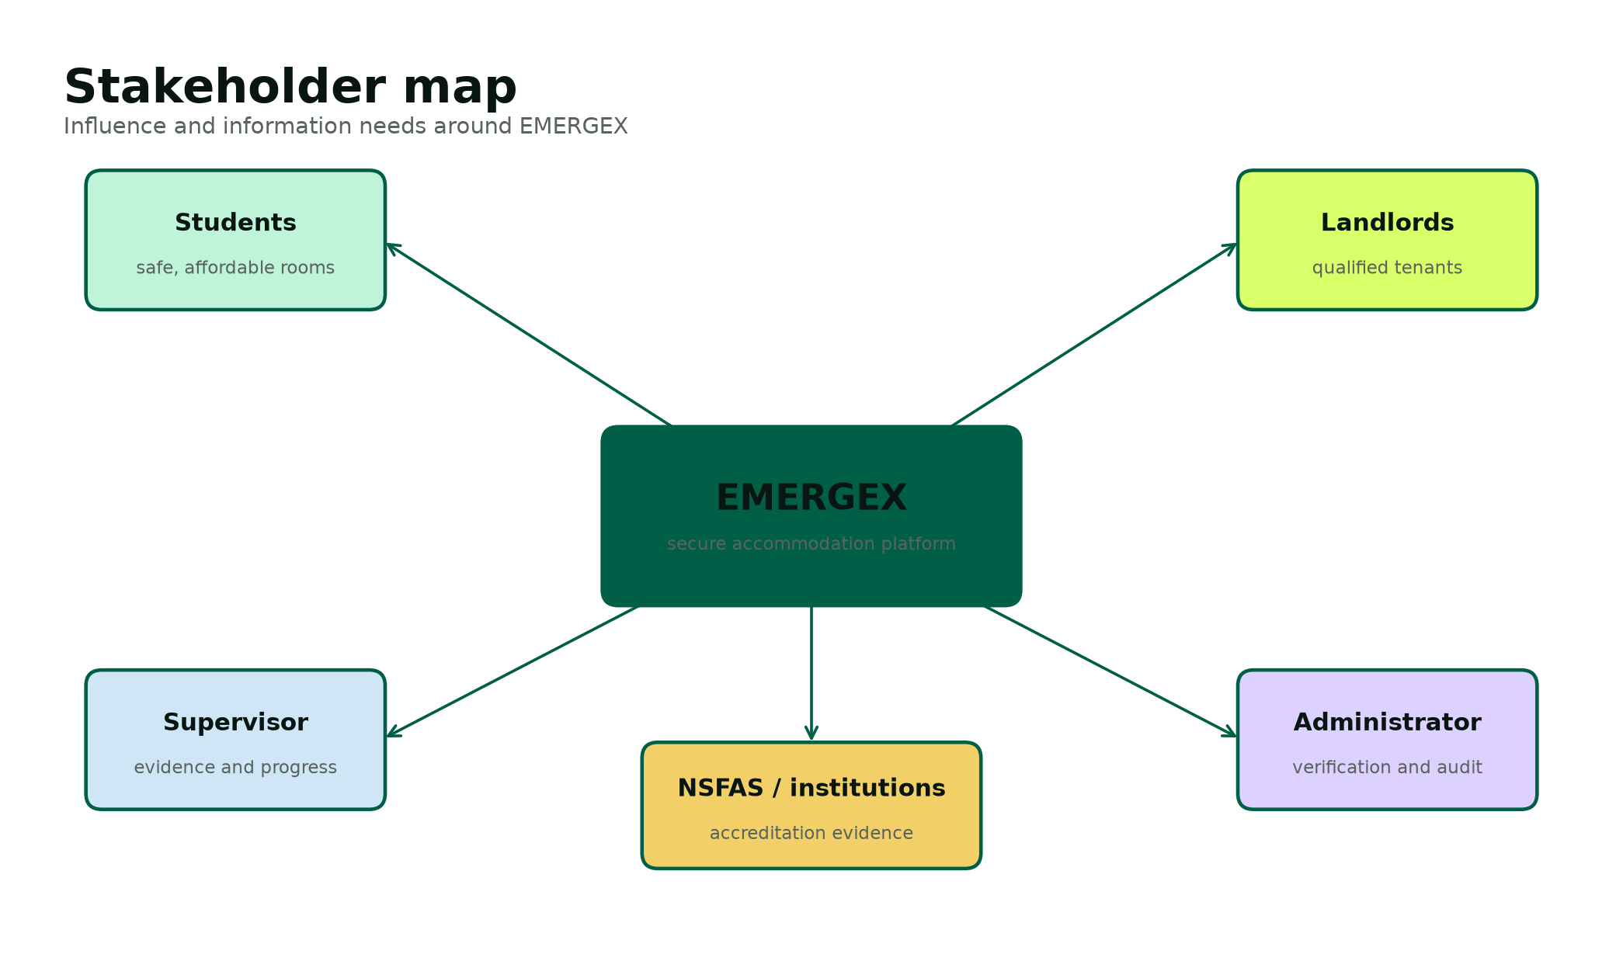
Figure 1. Stakeholder influence and information needs.
Table 1. Stakeholder register
Stakeholder | Interest | Influence | Information need | Engagement
Students | Safe, affordable and available accommodation | High | Price, distance, accreditation, visual proof, booking state | Usability reviews and acceptance tests
Landlords | Occupancy and credible applicants | High | Student request, move-in date, response deadline, deposit milestone | Workflow demos and dashboard review
Administrator | Platform trust and compliance | High | Verification queue, uploaded evidence and audit history | Weekly control review
Supervisor | Academic feasibility and evidence | High | Phase outputs, progress, risks and contribution | Scheduled reviews and approval gates
NSFAS / institutions | Accredited placement | Medium | Accreditation status and supporting evidence | Requirements validation; no live integration in prototype
Group members | Fair contribution and successful delivery | High | Backlog, owners, blockers and quality criteria | Twice-weekly stand-up and recorded minutes

Preliminary Investigation
The preliminary investigation combined the semester project guidelines, the existing Group 55 proposal, the EMERGEX pitch notes, official public information and an inspection of current accommodation marketplace behaviour. The investigation identified five recurring gaps to address in the prototype: fragmented discovery, uneven listing detail, uncertain verification, slow or invisible response status, and unsafe deposit behaviour outside a controlled workflow.
Table 2. Preliminary findings
Finding | Evidence or observation | Design response
Housing demand exceeds institutional supply | DHET reports document significant university and TVET accommodation shortfalls [1][2]. | Support private and institutional listings in a common search model.
Accreditation matters for funded students | NSFAS states that funded students should use accredited accommodation and that unaccredited providers may not be paid [3]. | Store and visibly filter NSFAS accreditation; require administrator review.
Existing marketplaces already provide useful search and contact | DigsConnect describes verified listings, search and direct contact [4]. | Do not copy blindly; focus differentiation on transparent states, visual evidence and response timing.
Landlord economics affect adoption | DigsConnect terms describe a fixed facilitation fee following confirmed tenancy [5]. | Document a lower-friction prototype model; defer final commercial pricing to validation.
Personal documents create privacy risk | POPIA governs lawful and secure processing of personal information [6]. | Collect the minimum, restrict access, validate uploads and define deletion expectations.

Feasibility Study
Table 3. Feasibility assessment
Dimension | Assessment | Conclusion / control
Technical | The team can build the required workflows with PHP, MySQL, HTML/CSS and JavaScript. XAMPP supports local deployment. Payment and identity integrations are beyond a safe student prototype. | Feasible when escrow and external integrations are simulated behind clear interfaces.
Operational | Students and landlords already use web and mobile channels. The workflow reduces informal hand-offs but requires administrator verification capacity. | Feasible with simple onboarding, status labels and an administrator queue.
Economic | The academic build uses open-source software and existing student devices. Production costs would be dominated by skilled labour, security, hosting and support. | Feasible for assessment; production requires staged funding and a validated revenue model.
Schedule | Five fixed due dates constrain the order of evidence. Parallel sprint work is needed between phase gates. | Feasible with the WBS, critical path, weekly integration and scope freeze after design.
Legal / ethical | POPIA, consumer law, property practice rules and payment regulation may apply. Real document and money handling would be high risk. | Prototype uses demo data and simulated funds; production requires professional compliance review.

Project Charter and Scope
Project charter
Deliver a demonstrable LAMP web application and complete SDLC evidence for Group 55 by 9 November 2026. The product shall help students discover verified accommodation, submit or instantly confirm a booking, simulate a protected deposit and confirm check-in, while landlords and administrators manage their responsibilities through role-specific dashboards.

Table 4. Scope boundary
In scope | Out of scope
Student, landlord and administrator registration/authentication | Real payment collection, custody, settlement or refunds
Verified property search, filters and rich listing details | Live NSFAS, university, identity-provider or bank integration
Standard booking with 12-hour response deadline | Legally binding digital lease execution
Instant Book for approved properties | Production-grade chat, SMS or WhatsApp delivery
Escrow lifecycle simulator and audit records | Native mobile applications
Validated demo document upload and review | Public production hosting with real personal documents
MySQL schema, seed data, installation and tests | Automated property inspections and legal accreditation decisions

Table 5. Key assumptions and constraints
Type | Statement | Planning response
Assumption | All six members can access Windows, XAMPP, Word and MS Teams. | Keep local setup documented and maintain one shared baseline.
Assumption | Supervisor feedback is available within approximately three working days. | Submit early enough to preserve correction time.
Constraint | Final academic due dates cannot move. | Treat phase dates as hard milestones and protect the critical path.
Constraint | No licensed payment or identity service is available. | Use explicit simulators and demo evidence only.
Constraint | The final report must be approximately 50-80 pages, excluding code. | Use a unified evidence-based report with numbered figures and tables.
Constraint | Every member must contribute and present. | Assign primary ownership, peer review and speaking sections.

Work Breakdown and Responsibilities
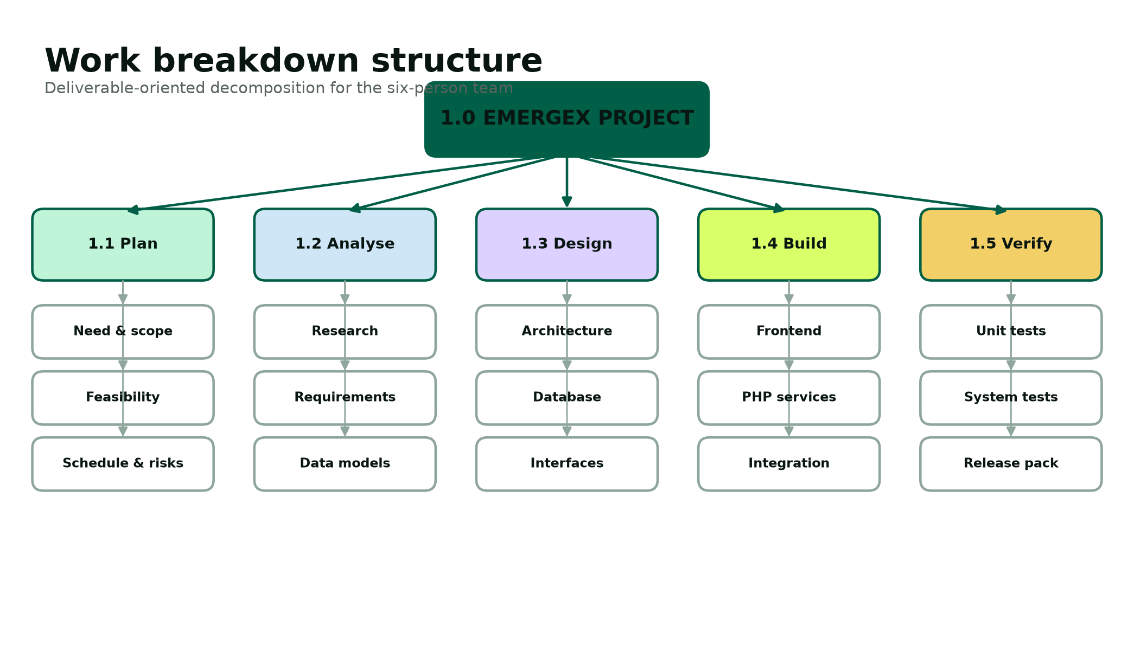
Figure 2. Deliverable-oriented work breakdown structure.
Table 6. Responsibility assignment matrix
Deliverable | Accountable | Responsible | Consulted / reviewer
Project baseline and supervisor coordination | Tristan | Tristan, Joyce | All members
Requirements and analysis | Joyce | Joyce, Lungelo | Tristan, Reenesh
UI/UX and responsive frontend | Thingo | Thingo, Tristan | Joyce, Lungelo
Database and backend services | Reenesh | Reenesh, Novithan | Tristan, Lungelo
Security and access control | Reenesh | Reenesh, Novithan | Lungelo
Testing and defect evidence | Lungelo | Lungelo, Reenesh | All feature owners
Documentation integration | Joyce | Joyce, Tristan | All members
Deployment and presentation | Tristan | Lungelo, Thingo | All members

Project Schedule
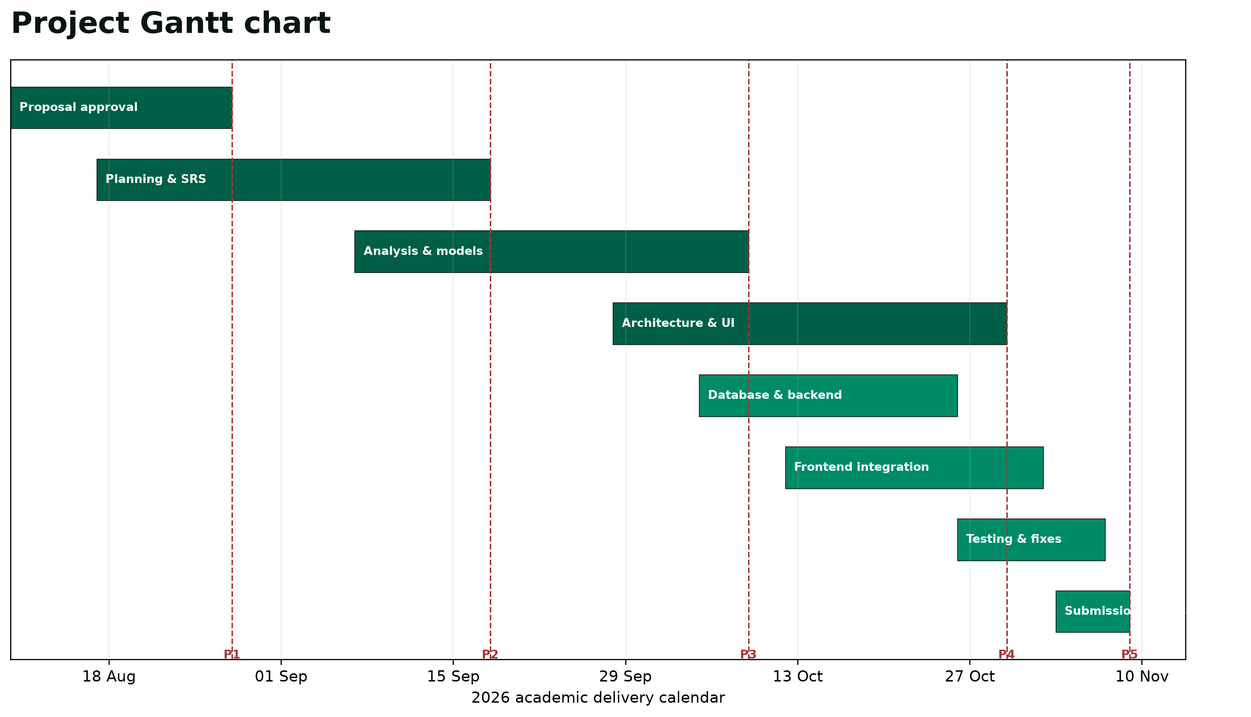
Figure 3. Gantt schedule aligned to the official semester deadlines.
Table 7. Milestone baseline
Milestone | Due date | Acceptance evidence | Owner
Phase 1 - Proposal | 28 Aug 2026 | Purpose, implementation language and SDLC approved | Tristan
Phase 2 - Planning | 18 Sep 2026 | Need, feasibility, WBS, Gantt, PERT, SRS and models | Joyce
Phase 3 - Analysis | 09 Oct 2026 | Methods, existing/proposed analysis and requirements | Joyce
Phase 4 - System design | 30 Oct 2026 | Architecture, database, pseudocode, UI and security design | Reenesh
Phase 5 - Implementation | 09 Nov 2026 | Code, test evidence, installation and final package | Lungelo

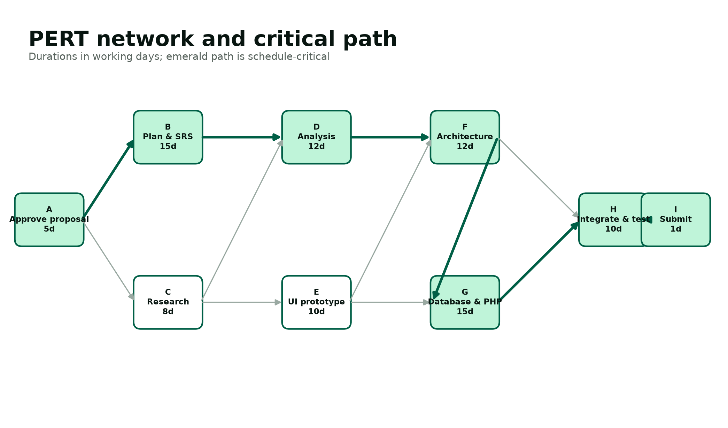
Figure 4. PERT network and critical path used for schedule control.
The critical path runs from proposal approval through planning, analysis, architecture, database/backend integration, system testing and submission. Activities such as research and early UI prototyping have limited float and may proceed in parallel, but their outputs must merge before the architecture and integration gates. If a critical activity slips, the team first reallocates members and reduces non-essential polish; it does not remove security controls, data integrity or required assessment evidence.

Risk Management
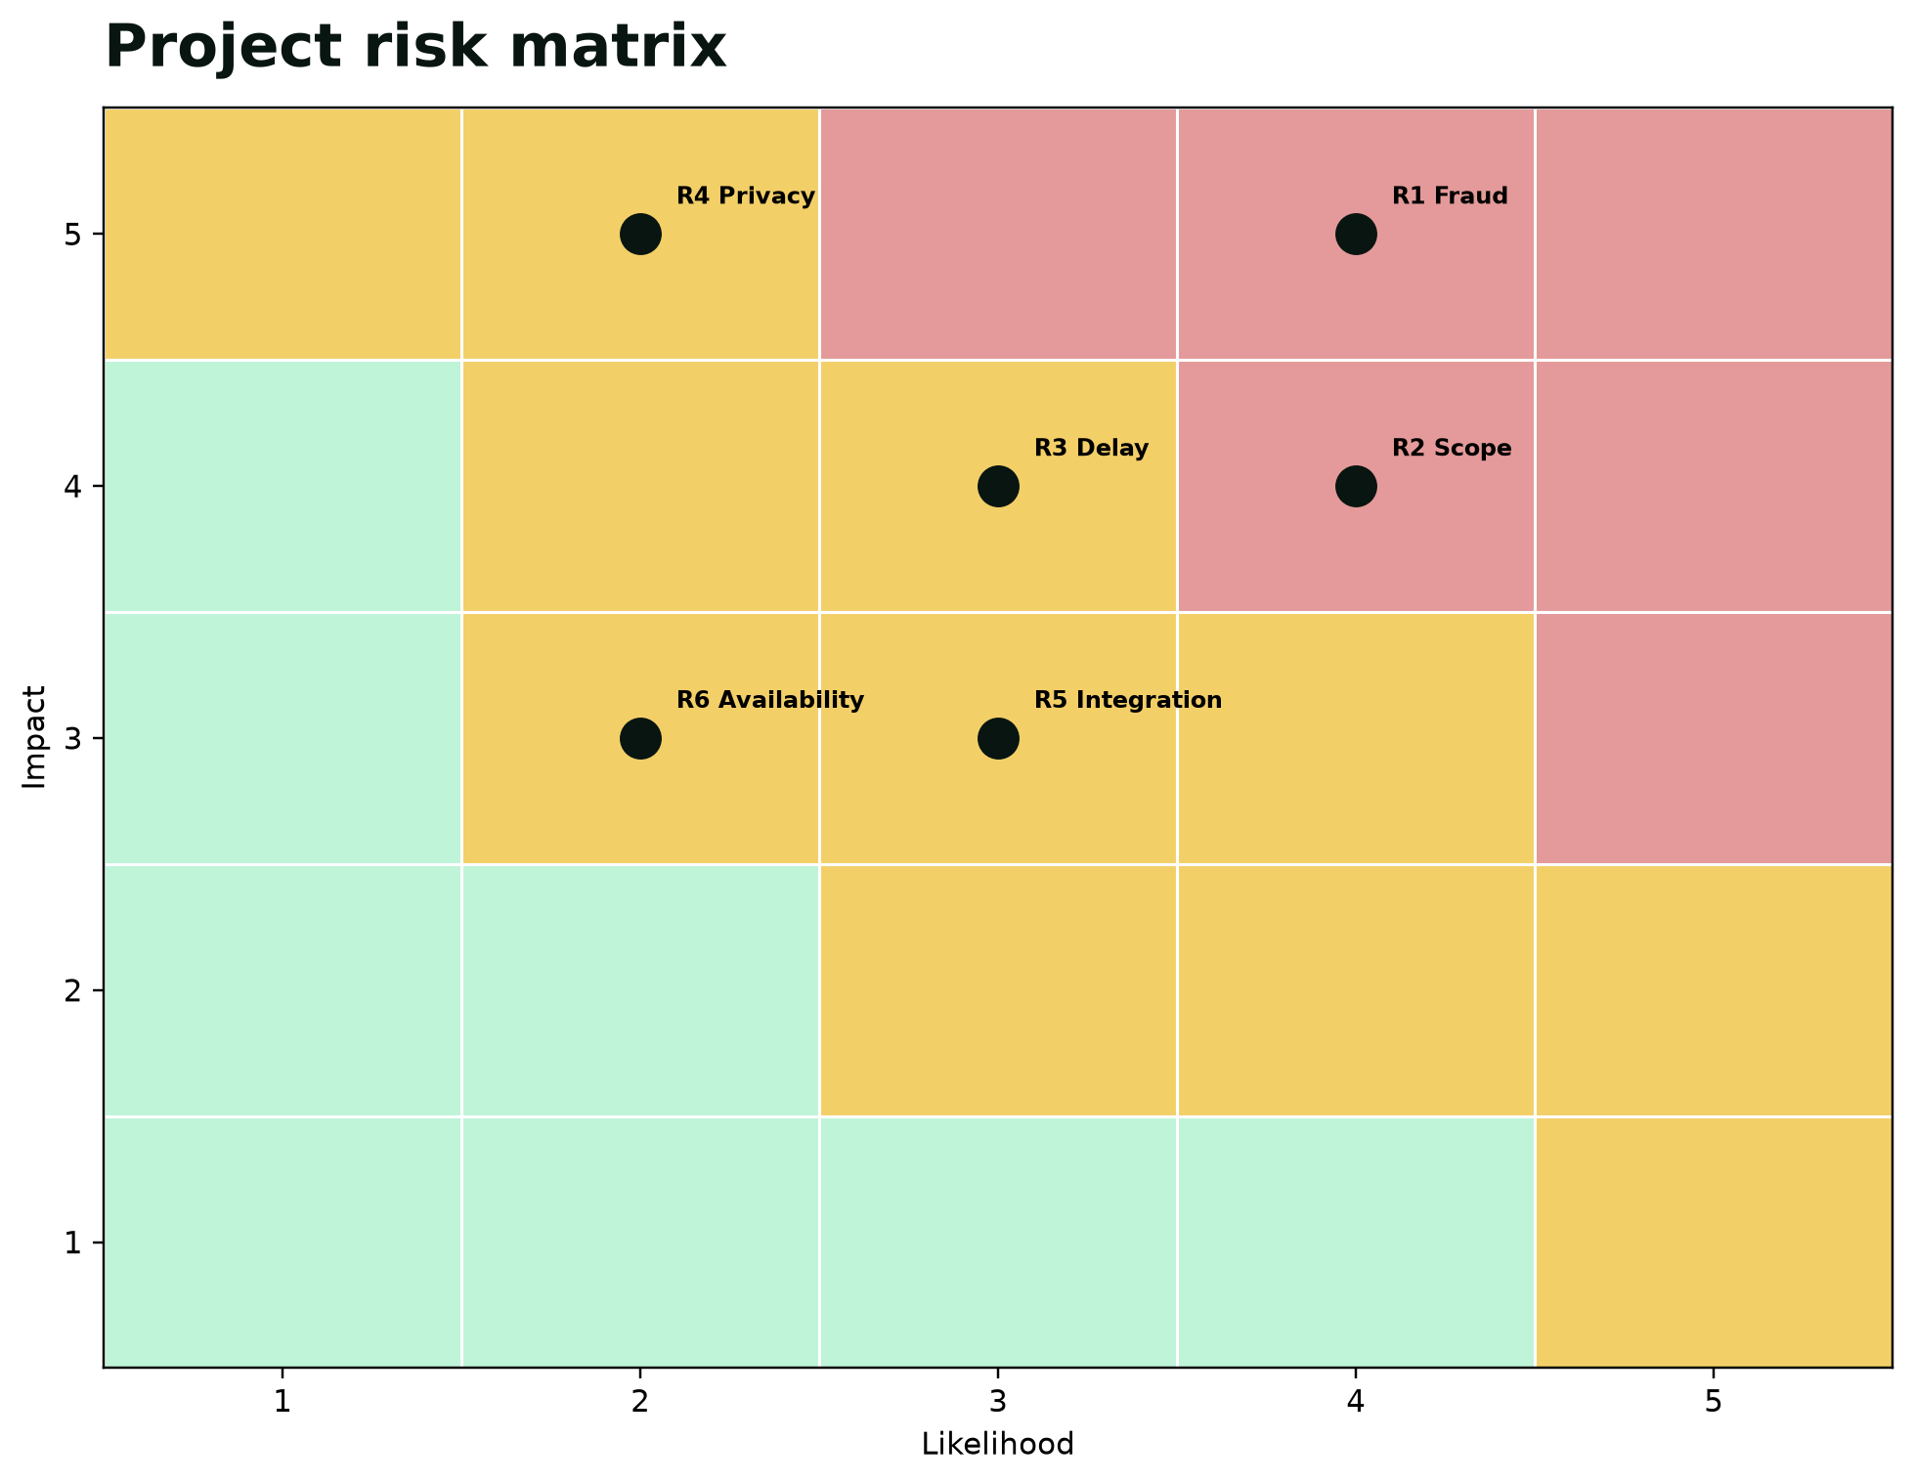
Figure 5. Likelihood-impact view of the principal project risks.
Table 8. Risk register
ID | Risk | L | I | Preventive control | Contingency / owner
R1 | Fraudulent property or landlord evidence | 4 | 5 | Administrator verification and visible status; audit events | Suspend listing and preserve evidence / Admin
R2 | Scope exceeds semester capacity | 4 | 4 | Freeze MVP after design; classify future features | Defer integrations and retain simulator / Project lead
R3 | Critical-path delay | 3 | 4 | Weekly milestone review; parallel ownership | Reassign members and shorten polish cycle / Lead
R4 | Personal-information exposure | 2 | 5 | Demo data only; minimal collection; restricted uploads | Delete affected data and investigate / Security lead
R5 | Frontend/backend integration defect | 3 | 3 | Shared data contract and early vertical slice | Rollback to last verified build / Backend lead
R6 | Member availability or contribution gap | 2 | 3 | Visible owners, meeting minutes and peer review | Rebalance tasks and inform supervisor / Lead
R7 | Database corruption or accidental reset | 2 | 4 | Schema in source control and backup procedure | Restore latest SQL backup / Database lead
R8 | Presentation failure or network interruption | 2 | 3 | Local deck, offline demo screenshots and rehearsal | Use recorded walkthrough / Presentation lead

Communication, Quality and Change Control
Table 9. Communication plan
Forum | Frequency | Participants | Purpose / record
Team stand-up | Twice weekly | All members | Progress, blockers, next actions; brief minutes
Integration review | Weekly | Developers, QA, analyst | Demonstrate vertical slice and log defects
Supervisor review | Per phase and when blocked | Project lead plus relevant owners | Approval, scope guidance and feedback record
Document peer review | Before every submission | Two reviewers not primary author | Rubric traceability, consistency and source check
Presentation rehearsal | Twice before panel | All members | Timing, handovers, individual questions and backup plan

A change request states the reason, affected requirement, scope impact, schedule impact, data/security effect, proposed decision and owner. The project lead may approve minor changes that do not alter a phase baseline. Material changes require the group and supervisor. Every accepted change updates the requirement traceability matrix and relevant test cases.

Software Requirements Specification Summary
The SRS is the controlled agreement between the approved need and the design. Requirements use stable identifiers so implementation and tests can be traced without relying on page location. The full functional and non-functional specification is developed in the analysis chapter; the planning baseline establishes user classes, interfaces and priority.
Table 10. User classes
User class | Characteristics | Primary goals | Privilege boundary
Visitor | Unauthenticated browser user | Browse published listings and understand safety process | Cannot book, upload or access dashboards
Student | Authenticated tertiary student | Search, book, track deposit state, upload demo NSFAS proof | Can access only own bookings and documents
Landlord | Authenticated accommodation provider | Manage own listings and respond to their booking requests | Cannot verify self or view unrelated properties
Administrator | Trusted operational reviewer | Verify entities, review documents and inspect audit events | Cannot impersonate users; actions are audited

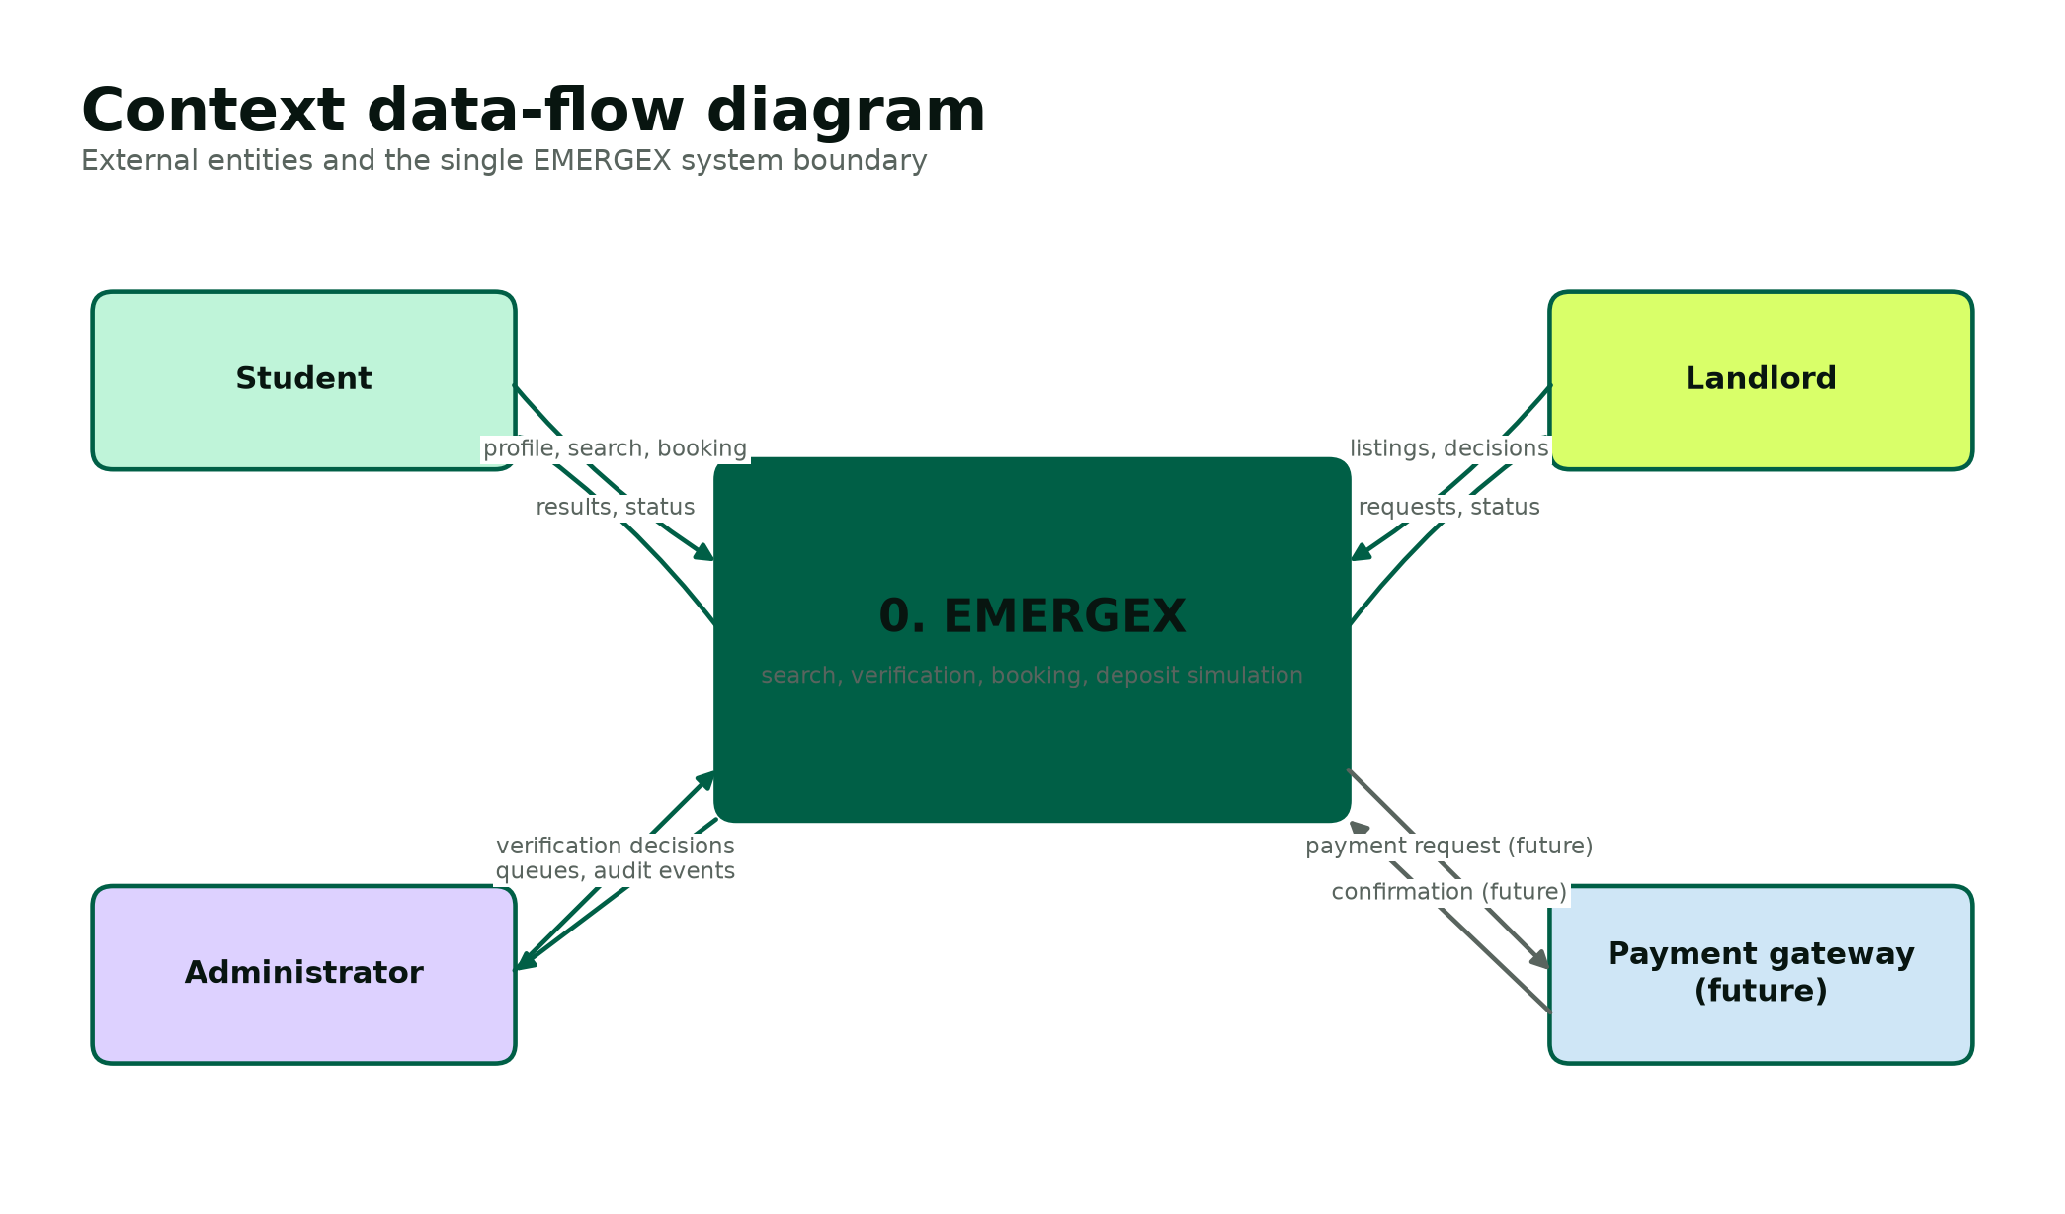
Figure 6. Context model included in the planning baseline.

Software Engineering Paradigm
The implementation follows a modular, transaction-oriented web paradigm. Presentation, application and data responsibilities are separated. Reusable bootstrap functions centralize database access, escaping, session security, CSRF, role enforcement and audit recording. Each public page performs one coherent workflow and applies server-side ownership checks. Database transactions protect multi-table booking and escrow changes. This structure is deliberately simpler than a large framework but preserves the design principles needed for maintainability and testability.

References
[1] Department of Higher Education and Training. Report on the Ministerial Committee for the Review of the Provision of Student Housing at South African Universities (2011). https://www.dhet.gov.za/ResearchNew/39.%20Student%20housing%20at%20South%20African%20universities.pdf
[2] Department of Higher Education and Training. Student Housing Symposium keynote address (2016). https://www.dhet.gov.za/SiteAssets/Minister%20Speech%202016/Student%20Housing%20Symposium%20Minister%20Speech%2021%20July%202016.pdf
[3] National Student Financial Aid Scheme. Registering accommodation properties and student accommodation guidance. https://nsfas.org.za/content/studentacom.html
[6] Republic of South Africa. Protection of Personal Information Act 4 of 2013. https://www.justice.gov.za/legislation/acts/2013-004.pdf
[7] PHP Documentation. password_hash and password_verify guidance. https://www.php.net/manual/en/function.password-hash.php
[8] PHP Documentation. PDO::prepare and parameter binding. https://www.php.net/manual/en/pdo.prepare.php
[9] OWASP Cheat Sheet Series. Authentication and Session Management guidance. https://cheatsheetseries.owasp.org/cheatsheets/Authentication_Cheat_Sheet.html
Project source: IT PROJECT GUIDELINES SEMESTER 2 2026.pdf and the original Group 55 Phase 1 / EMERGEX pitch documents.

